University of Zurich Prof. XXX
Study Coordination Biodiversity Department XXX
Winterthurerstrasse 190 e-mail
CH-8057 Zurich

Place, Date

Master of Science in Biodiversity

Student's first name, Last name Matriculation Number

EEE 520: Integrated knowledge (10 ECTS)

Name of student passed / did not pass the module EEE 520 with the following grades:

Oral exam grade: XXX (to the nearest half) | Date: xx.xx.20xx

Co-examiner(s): Name(s)

Brief Justification by the MSc Supervisor

For the oral exam grade:

Provided that all other requirements are met, in my view, the Master’s degree may be awarded to name of student.

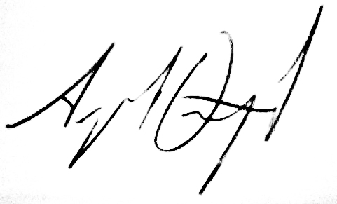
Master Thesis Supervisor Master Coordinator
Prof. XXX Prof. Arpat Ozgul

Please send completed form to Prof. Arpat Ozgul arpat.ozgul@uzh.ch

